Instructions for the activities Day 27/04/2020- 01/05/2020

Please read the instructions and follow the indications.

SPELLING WORDS:
1. Archaeology
2. Document
3. Era
4. Evidence
5. Expedition
6. Permanent
7. Tremendous
8. Uncover
9. Science
10. Ancient

- With the Spelling words you will search the meaning of all the words.
Example: Archaeology- Arqueologia

- Then you are going to make a story using the words that you have on the spelling words
(Usa las palabras del spelling words para hacer una historia inventada por ti, puedes hacer dibujos)

Reading Writing:
- Write in the notebook, the lecture of AN OLD MAN LIVED IN THE VILLAGE.
- (Escriban en el cuaderno la lectura de AN OLD MAN LIVED IN THE VILLAGE.)
- Read the lecture complete at home, use a cellphone or PC to record your reading of the first page of the lecture and send it to me.
- (Lean la lectura complete en casa, después graben su voz leyendo la lectura para poder escuchar su entonación, después mándenme sus grabaciones)

Grammar:
Copy the prepositions of location on a piece of paper

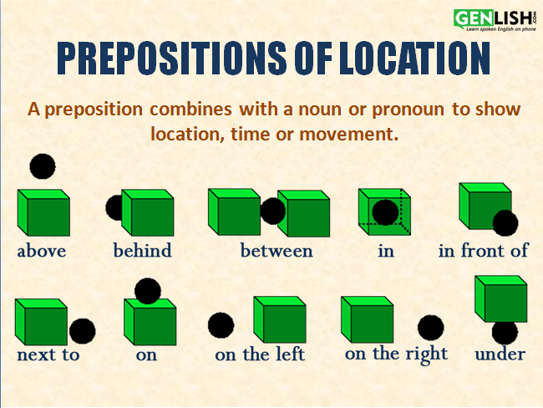

EXAMPLES:

The bookstore is beside the coffee shop.
The movie theater is next to the library.
The bus stop is near the school.

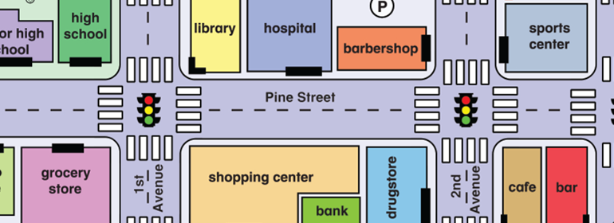

Use what you know and answer the question below.

- Where is the BARBER SHOP?

- Where is the HIGH SCHOOL?

- Where is the BANK?

- Where is the CAFE?

- What is in front of the GROCERY STORE?

- What is behind the SHOPPING CENTER?

- What is beside of the CAFE?

- What street do you need to take to go from the SPORT CENTER to the GROCERY STORE?

