Work plan for 3 grade
Today is Tuesday April- 21 -2020

Today we are going to work with the activity book on pg.91
We are going to work working with wath we stay behind.
We are working on unit -9pg.91 some of you student are not in that pg.the only thing you have to do fallow directiones ok.and i am here to help you ok.try to do as much as you can ok.
You can see that you have the book and the instructions and try to do all the exercise

Complet the conversatin with the correct word
When / Who / Why
1.______________is your mom going to the store.
2.______________are you runing.
3.______________are we going to the movies.
4.______________is she going to clean the room.
5.______________are they going top lay.
6.______________ are they coming.
7.______________are those people
8.______________is your birthday.
9.______________is she.
10._____________is the day for the park.

Make a drawing at your house what are you doing.
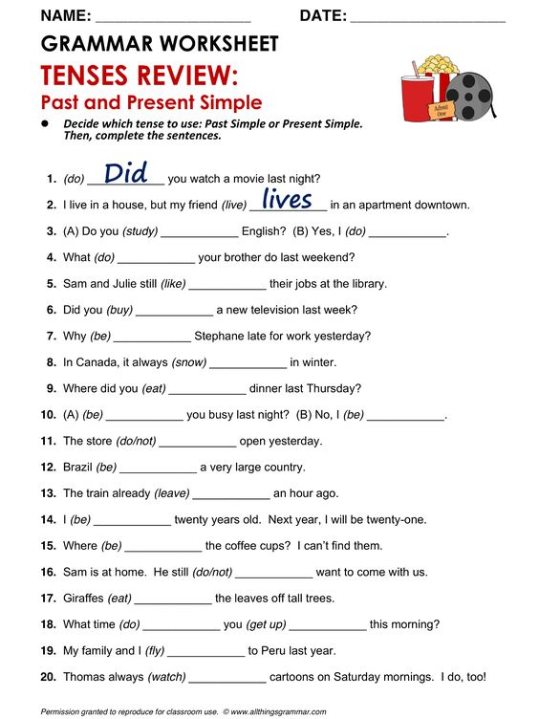
SPELLING WORK PUT THE WRITE WORD ON THE BLANK.

1.______AIR 2. _____UMB 3. ____ARK 4. _____ERRY

5.____EEL 6. _____EEP 7. ____ISTLE 8. _____ORN

W---TH---H—SH—S---W---SH---H

WRITE ONE SENTENSES WITH EACH WORD THIS IS SPELLING.

1.bread ___________________________________________________
2dip ___________________________________________________
3.Fry ___________________________________________________
4.Cut ____________________________________________________
5.Chop ____________________________________________________
6.Roast _____________________________________________________
7.Slice _____________________________________________________
8.Better ______________________________________________________
9.Brought ______________________________________________________
10.Clean done ______________________________________________________
11.Draw _______________________________________________________
12.drink ______________________________________________________
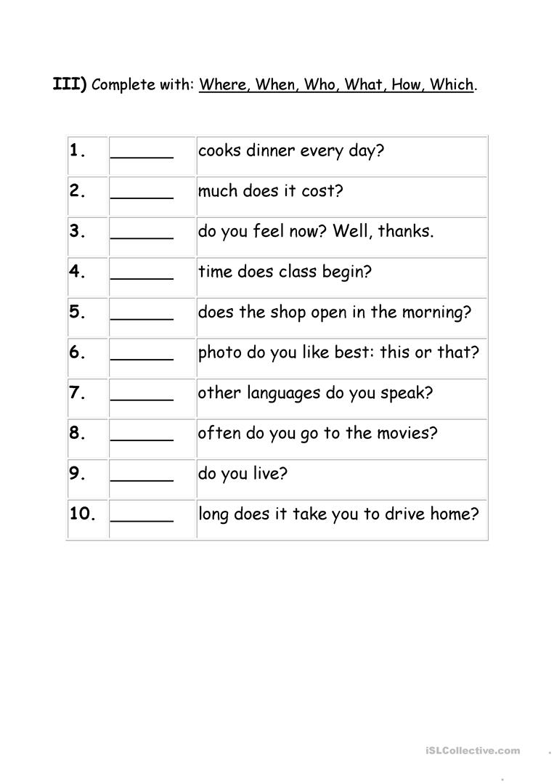
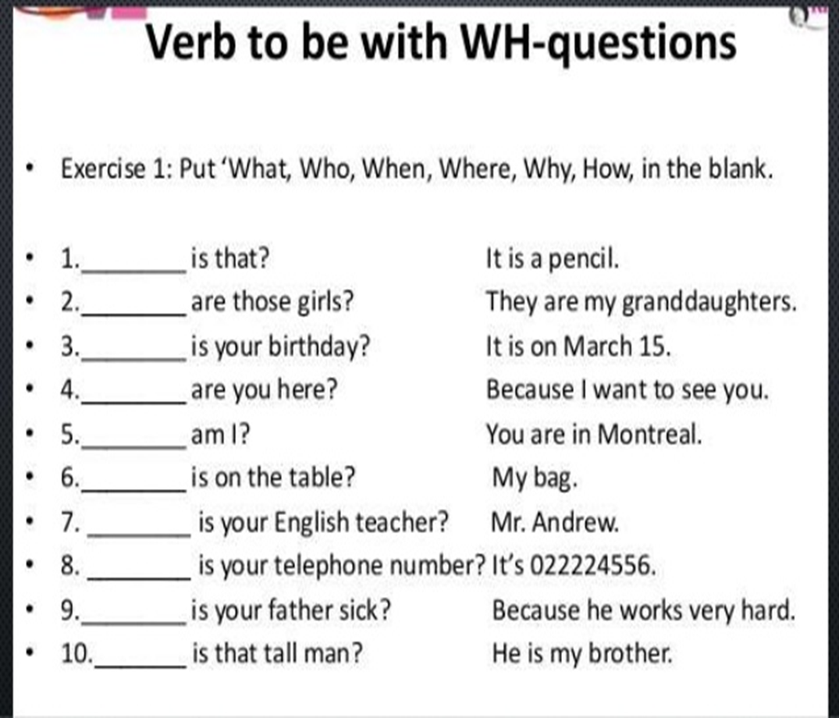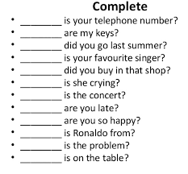

Complete with the Word( what)

Match the words with the picture

1.statue -------------- ( )
2.painter---------------( )
3.celing-----------------( )
4.pay-------------------( )
5.sculptor------------------( )
6.chapel-------------------( )
7.pope----------------( )
8.above------------------( )
9.dangerous----------------( )
10.paint------------------------(

Unscramble the words.

1.etatus ______________
2.Gecilin ______________
3.tolspruc _____________
4.palche _____________
5.inperat _____________

MATCH THE WORD WITH THE DIFINITION.
1.The Surface that is above you in a room. Statue
2.An artista who Paint pictures. Chaple
3.Acarved figure of apersono r an animal sculptor
4.A building like a church. celling

Complete the text
The Pope asked Michelangelo to
Do a new 1.______________on the
Ceiling of the Sistine Chapel.How can
You Paint a ceiling? Michelangelo
Made a 2.__________and he lay on
His back on this scaffold Michelangelo
Worked on the ceiling3._____________and
People walked on the floor4.______________him.
The Pope visited Michelangelo many times .He
Said ,Is the painting 5.____________?
Michelangelo said ,No .It s not ready!
Paint 6._______________!shouted the Pope. Finally ,
After four years and four month, the ceiling was finished.

