MAKE A STORY WATH YOU ARE DOING AT HOME
1.________________________________________________________
__________________________________________________________
__________________________________________________________
__________________________________________________________
__________________________________________________________

Make 5 sentences with (singular) words
How much
1._________________________________________.
2._________________________________________.
3._________________________________________.
4._________________________________________.
5._________________________________________.

Make 5 sentences with ( plural.)
How much are
1.__________________________________________.
2.__________________________________________.
3.__________________________________________.
4.__________________________________________.
5.__________________________________________.
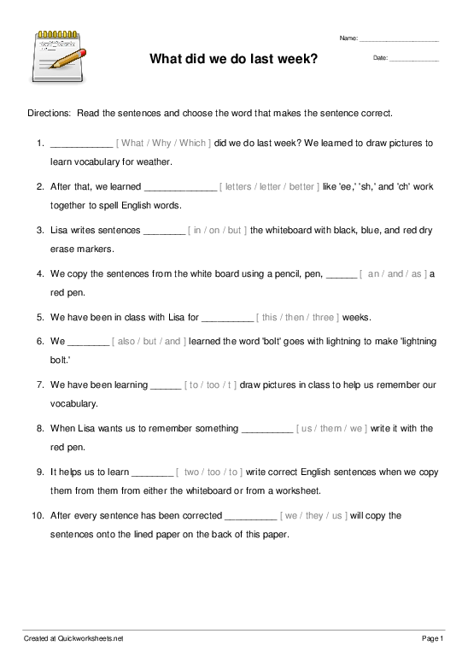
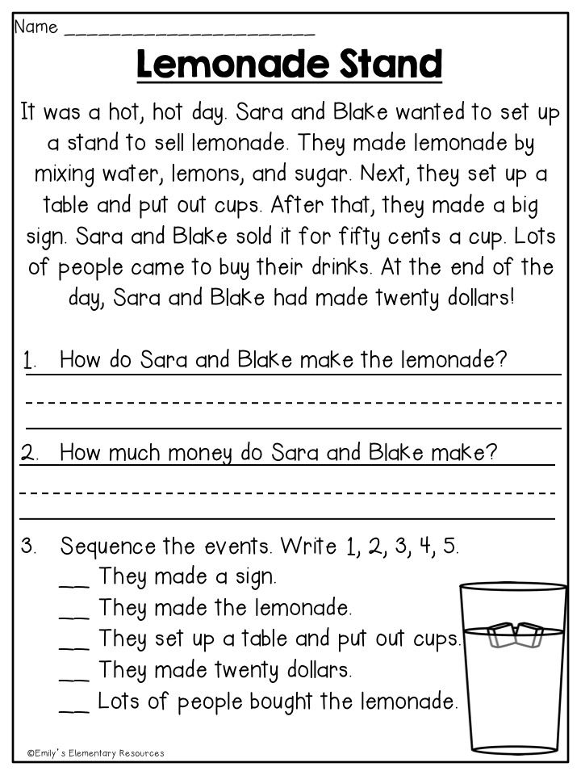
CAPITAL LETTER THAT NEED THE SENTENCES.
