WATH IS YOUR FAVORITE PET?
________________________________________________________
1.REASON #1_____________________________________________
________________________________________________________
________________________________________________________
2.REASON#2_____________________________________________
_______________________________________________________
________________________________________________________
3.REASON#3______________________________________________
_________________________________________________________
_________________________________________________________
RESTATE YOUR OPINION
_________________________________________________________
_________________________________________________________

MAKE A DRWING OF YOUR PAT AND COLOR.

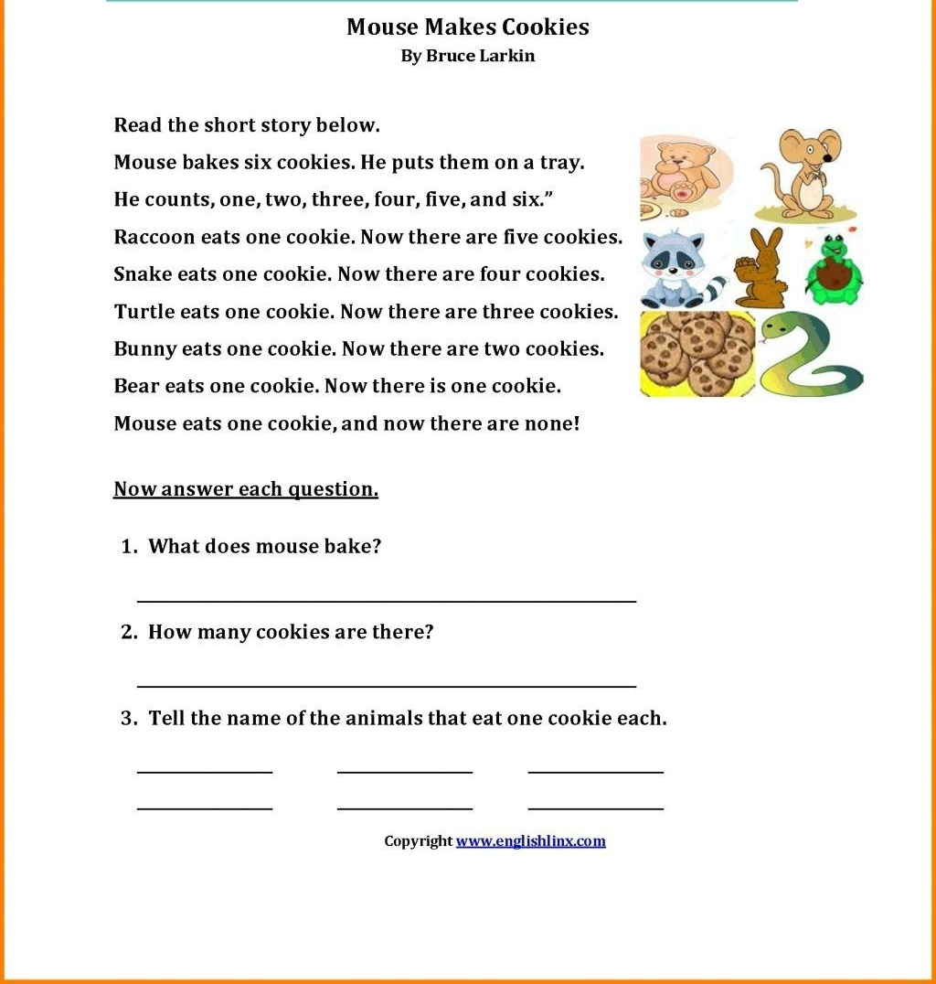

ANSWER THE QUESTION LOOK AT THE PICTURE.

HOUSE OR SCHOOL
DO YOU LIKE SCHOOL OR HOUSE?

1.I LIKE ___________________________________________________.
_________________________________________________________.

2.BECAUSE________________________________________________.
_________________________________________________________.

MAKE A DRAWING OF YOUR SCHOOL OR HOUSE AND COLOR.

1.TELL HOW MANY PATS DO YOU HAVE EXPLAING.

1.

UNDER LINE THE CORRECT ANSWER

1.When you ______________materials, you make them into something else.
A.clean
B.recycle
C.buy

2.The pitcher can ____________________the ball fast.
A.throw
B.eat
C.sleep

3.The __________________bottle can be recycled.
A.trash
B.plastic
C.flyer

4.they are _________________at the beach.
A.throwing
B.sleeping
C.cleaning

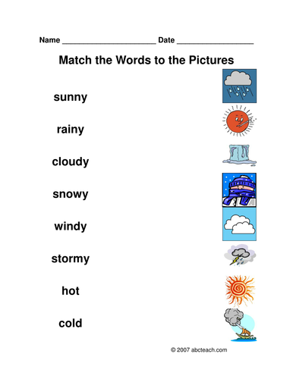
MAKE A STORY OF ALL THE THINGS THAN YOU ARE LOOKING NOW.

1.MAKE A EXPLENASION STEP BUY STEP.

2.MAKE A SENTENCES WITH THIS WORDS.
TRASH – PLASTIC – CLEANING -COMMUNITY – VERTICAL

1.
2.
3.
4.
5.

