Complete the sentences.
Beach / ciean / community / ecological / flyers / helpful /
Partners / plant / recycle / supportive / together / trash

Some people were offering _____________ in the mall. Itook
One ,they announced an _______________ evento to __________
The ___________ because it was very dirty.
I called my Friends and asked them to join me. They agreed because they
Understand it is very _______________ for the environment to work
______________________ to improve our ______________.
We were very _______________ with the association in charge of the evento, we ever became
_______________.Now we do this kind of event very often ,we also___________
Wastes and _____________ tres.

Use the code to discover the words.
Complete the sentences.All the number go with the letter .
A -B- C -D -E -F -G -H -I -J - K - L - M N -O -P -Q -R -S -T U -V -W -X Y -Z
1 -2- 3- 4 -5 -6 -7 -8 -9 -10 -11 -12 -13 14 -15 -16 -17 -18 -19 -20 -21 -22 -23 -24 -25

__________________ ____________________ _____________________
10- 15 – 2 23 -15 -18 -11 20 – 8 -18 -15 -23

_________________ _____________________
13 -5 -19 -19 -25 16-12-1-19-20-9-3
Unscrable the words.
3.please putt he (shart ) in the trash can! _____________.
4.The ecological association use dan (vesidtartemen) to invite people to the evento.
6.It is my obligation to (nelca)the backyard in my house .
7.It is everybody¨s( boj)top ut the wastes on thir place.
9.Taking careo f the enviroment is easy if we do it (totgereh).
10.In the evento they gave more (Lfyres) to the people.

1.The community (nargiezoz ) evento to clean the beach.
2.We gather (rppae)like newspapers and old notebooks to recycle it.
5.In my family we (rpuspot) ecology.
8.It is very (Lpehlfu) if you smash your plastic bottles before throwing them,that way they occupy les space.

TODAY WE ARE GOING TO DO SOME EXTRA WORK.AND THIS WEY WE ARE GOING TO BE DOING.
MOM,DAD WE ARE GOING TO STAR WORKING LITTER BY LITTER
WITH SOME EXTRA WORK AND SOME EXTRA ACTIVITYS.I HOPE YOU ALL
AUNDER STAN ALL THIS WHAT IS GOING ON .DAD ,MOM TRY TO HELP YOUR KID
AS MUCH AS YOU CAN .AND IF YOU NEED HELP LET ME KNOW WATH TO DO SO I
CAN HELP YOU. THIS IS FOR 4 GRADE.PLEASE MOM AND DAD TELL YOU KIDS TO PUT
THE DAY AND THE MONTH AND YEAR .IN ALL THE WORK THAT IAM SANDING.
THANKYOU VERYMUCH FOR YOUR HELP

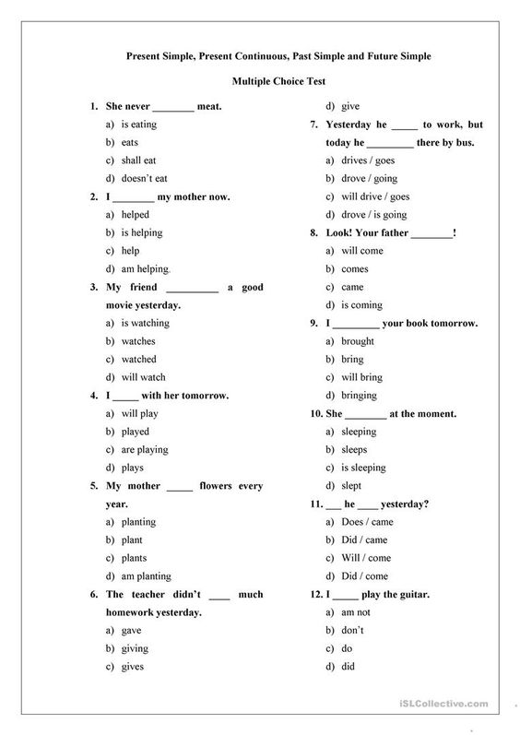
MAKE A STORY OF ALL THIS WORDS THAT I AM GOING TO SANDING YOU .
THE SECOND PART ON THE BOTTOM OF THIS PG OK.DATE PLEASE

1.park
2.games
3.trees
4.grass
5.swings
6.balls
7.boys
8.girls
9.toys
10.chairs

IS HERE
You are going to write the story on this part .

UNDER LINE THE CORRECT OPTION DATE PLEASE.
1.I drink__________ because i was runing
Wáter / cake / candy
2.Today i was sick i want to ____________
School / Doctor / store
3.I have to ___________ school in the morning.
Run / walk / go
4.My mom is very ___________.
Sad / pretty / crying
5.I have to do some __________at home
Extra / work / job
6.I am taking my dog to my _______________.
Grandparen / car / school
7.every day i clean my ___________
Dish / room / box
8.Today iam going to work on the _____________.
Park / store / exames
9.My favirote store is in the_____________.
Store / mall / outside
10.I go to ___________ every day.
Eat / school / play

Spelling words write 2 times each Word. Date please

1.about _____________ ______________
2.after _____________ ______________
3.agin _____________ ______________
4.always _____________ ______________
5.jump _____________ ______________
6.keep _____________ ______________
7.kind _____________ ______________
8.think _____________ ______________
9.those _____________ ______________
10.three _____________ ______________
11.step _____________ ______________
12.scram _____________ ______________
13.craft _____________ ______________
14.people _____________ ______________
15.page _____________ _______________

Write 5 sentences what are you going to do when you came back to school.

1.______________________________________________________________.
2.______________________________________________________________.
3.______________________________________________________________.
4.______________________________________________________________.
5.______________________________________________________________.

