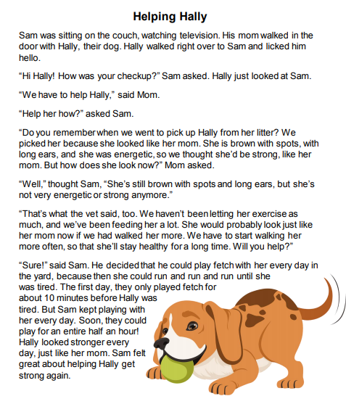

Questions:

1. Recount the story in your own words.
_______________________________________________________
_______________________________________________________
2. How did Hally change throughout the story?
_______________________________________________________
_______________________________________________________
3. What are the problem and solution in the story?
_______________________________________________________
_______________________________________________________
4. How did Hally’s environment change her traits?
_______________________________________________________
_______________________________________________________

5.What was Sam doing on the beginning of the story?
_______________________________________________________
_______________________________________________________
6.Why the mom tells Sam that they have to help Hally?
_______________________________________________________
_______________________________________________________

7. How was Hally when they were to pick her from her litter?
_______________________________________________________
_______________________________________________________
8. How is Hally physically?
_______________________________________________________
_______________________________________________________
9. What is the best exercise for Hally?
_______________________________________________________
_______________________________________________________
10. How many minutes did they play the first time before Hally became tired?
_______________________________________________________
_______________________________________________________

11. How many minutes did they were able to play the second time?
_______________________________________________________
_______________________________________________________
12. What is the picture showing you on your words?
_______________________________________________________
_______________________________________________________

13. What pet have you had?
_______________________________________________________
_______________________________________________________
14. What pet would you like to have?
_______________________________________________________
_______________________________________________________

15. Describe what would you play with your pet?
_______________________________________________________
_______________________________________________________

