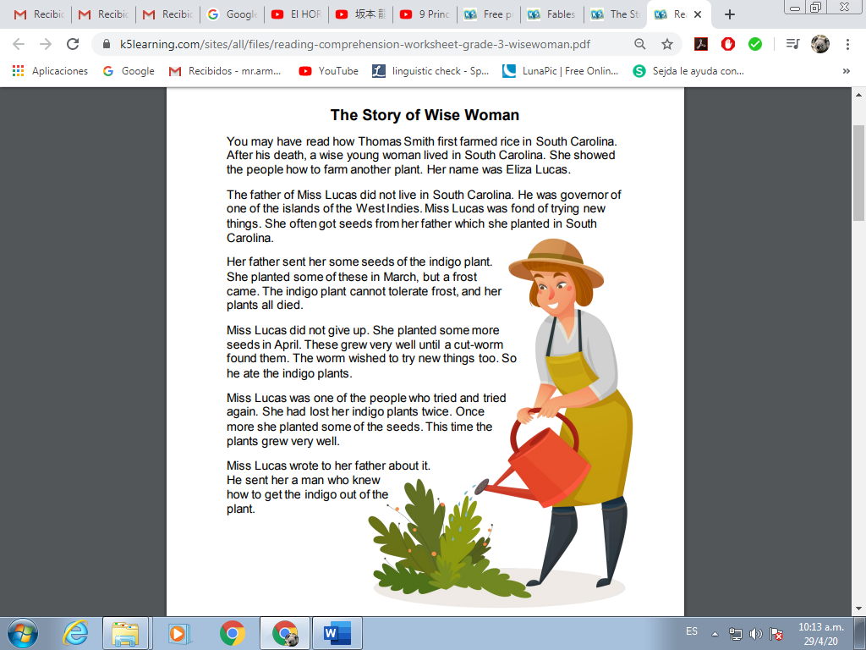
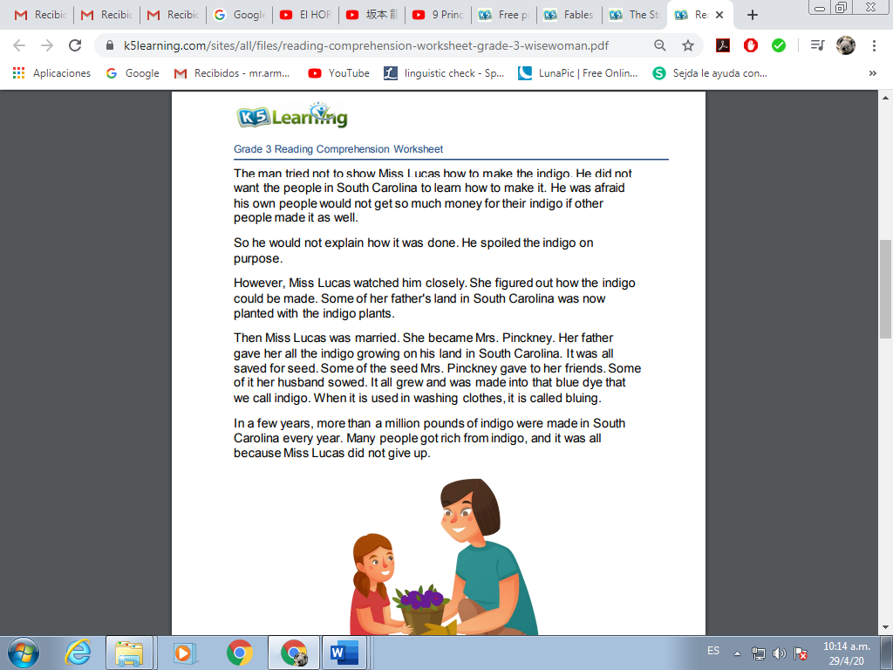
Questions

- What happened to the indigo plants the first time?

- How did Miss Lucas help the people of South Carolina?

____________________________________________________________

- How would you describe Miss Lucas?

__________________________________________________________________

- Why do you think Miss Lucas was Successful?

__________________________________________________________________

- Where did the father of Miss Lucas lived?

- Where was the father of Miss Lucas governor?

____________________________________________________________

- Why do you think the Indigo plants die the first time?

- When did she planted more seeds the second time?

____________________________________________________________

- What happened to the indigo plants the second time?

- Did Miss Lucas give up after the second failure?

____________________________________________________________

- Why do you think is important to not give up?

- Why the man didn´t wanted to show how to make indigo plants?

- What was the name of Miss Lucas after she got married?

- How is it called when you use the Indigo on washing clothes?

____________________________________________________________

- In a few years after that how much indigo was made on South Carolina?

