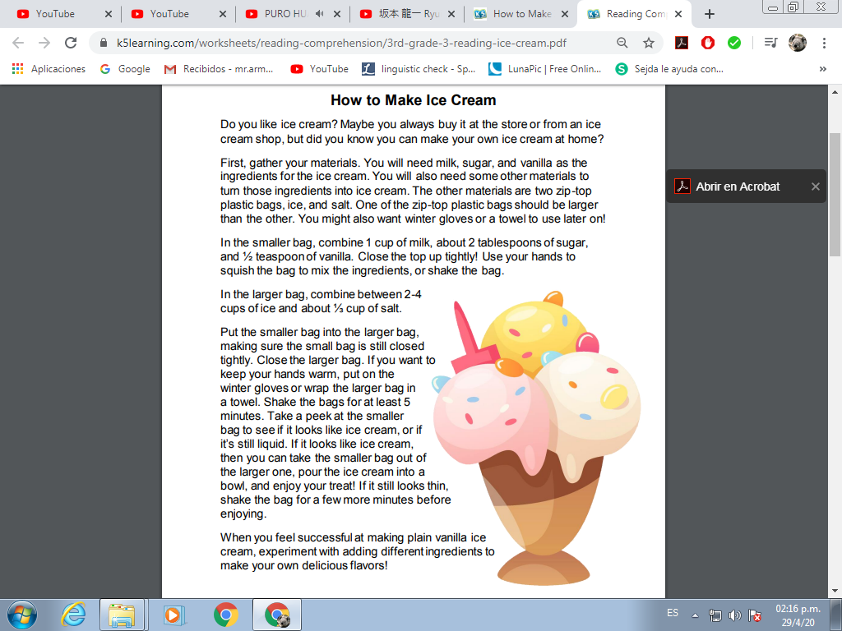

Questions:

1. What is the short story mostly about?
_______________________________________________________
_______________________________________________________

2. If you were going to add in your own ingredients, which paragraphs
would you need to add more information to?
_______________________________________________________
_______________________________________________________

3. What is the main topic of the second paragraph?
_______________________________________________________
_______________________________________________________

4. How do you know it’s time to stop shaking the bags?
_______________________________________________________
_______________________________________________________

5. What does the word “combine” mean in the third paragraph?
_______________________________________________________
_______________________________________________________

6. What do you need to do first to start the recipe?
_______________________________________________________
_______________________________________________________

7. Do you like Ice cream?
_______________________________________________________
_______________________________________________________

8. Why do you like/ don´t like Ice cream?
_______________________________________________________
_______________________________________________________

9. What are the ingredients of the ice cream?
_______________________________________________________
_______________________________________________________

10. What flavor is the ice cream that the recipe shows?
_______________________________________________________
_______________________________________________________

11. What is your favorite flavor of ice cream?
_______________________________________________________
_______________________________________________________

12. Have you made ice cream before?
_______________________________________________________
_______________________________________________________

13. How much time do you need to shake the bags?
_______________________________________________________
_______________________________________________________

14. What is the picture showing in your words?
_______________________________________________________
_______________________________________________________

15. What is the meaning of successful?
_______________________________________________________
_______________________________________________________

