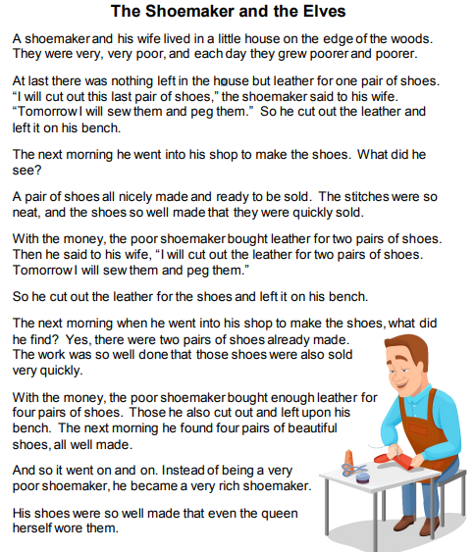

Questions:

- Who helps the shoemaker make the nice shoes?

_______________________________________________________

2. What does the shoemaker buy with the money he makes selling
shoes?

_______________________________________________________
3. Which word best describes the shoemaker?

_______________________________________________________
4. What might have happened if the shoemaker got no help?

_______________________________________________________

5. Where did the shoemaker and his wife lived?

_______________________________________________________
6. They were rich or poor?

7. What might have happened if the shoemaker got no help?

_______________________________________________________

8. Would you like the shoes of the shoemaker?

_______________________________________________________

9. How much money do you think are worth your shoes?

_______________________________________________________

10. What did the shoemaker become after some time?

_______________________________________________________

