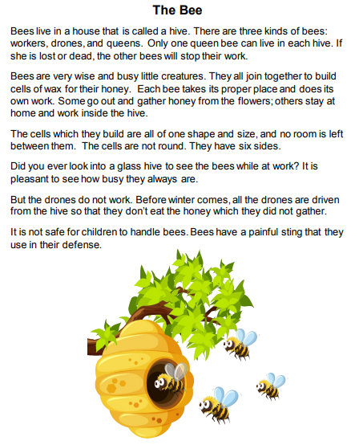

Questions:

1. How many sides does a cell in the hive have?
a. Three
b. Four
c. Six
d. Seven

2. What happens to the drones in the winter?

a. They sleep.
b. They find a new hive.
c. They are driven out.
d. They repair the hive.

3. Which is not a kind of bee?

a. Workers
b. Kings
c. Queens
d. Drones

4. Which word best describes bees?

a. Hard-working
b. Lazy
c. Stupid
d. Cuddly
5. How do you call to a home of the bees?
_______________________________________________________
_______________________________________________________

6. How many queen bees must be on a hive?
_______________________________________________________
_______________________________________________________

7. What happens when the queen bee dies or is missing?
_______________________________________________________
_______________________________________________________

8. What is the job of the workers?
_______________________________________________________
_______________________________________________________

9. What is the defense of the bees?

a. They sleep.
b. They use a sting.
c. They play dead.
d. They have swords.

10. Does the cells they do have different shapes?

a. Yes
b. No
c. Some times
11. Which word best describes bees?

a. Animals
b. Reptiles
c. Insects
d. Plants

12. Are the bees always busy?

a. Yes
b. No
c. Some times

13. Where have you seen bees before?
_______________________________________________________
_______________________________________________________

14. Do you like bees?
_______________________________________________________
_______________________________________________________

15. Why do you like/ don´t like bees?
_______________________________________________________
_______________________________________________________

