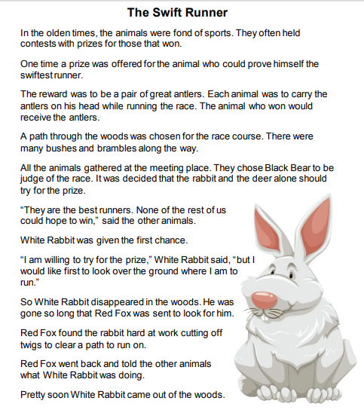

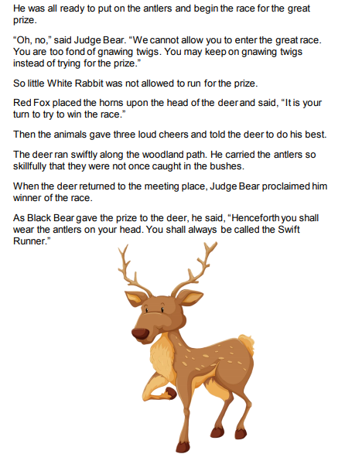

Questions:
- What could slow the runners down on the path?

_______________________________________________________

- Why is White Rabbit not allowed to run?

_______________________________________________________

- Why do you think the other animals did not want to race?

_______________________________________________________

- Which word best describes Judge Bear?

_______________________________________________________

- What can you see on the images that are showed?

_______________________________________________________

- What did the animals liked to do on the olden time?

_______________________________________________________

- What was offered to the swifter runner?

_______________________________________________________

- What kind of things were along the way of the race?

_______________________________________________________

- Who was chosen as judge?

_______________________________________________________

- Who was the first that was given the chance?

_______________________________________________________

- Who was sent to go look for the rabbit?

_______________________________________________________

- Do you think what the rabbit did was wrong?

_______________________________________________________

- What would you have done in a situation like that?

_______________________________________________________

- Why the animals were angry with the rabbit?

_______________________________________________________

- Who became the winner at the end?

_______________________________________________________

