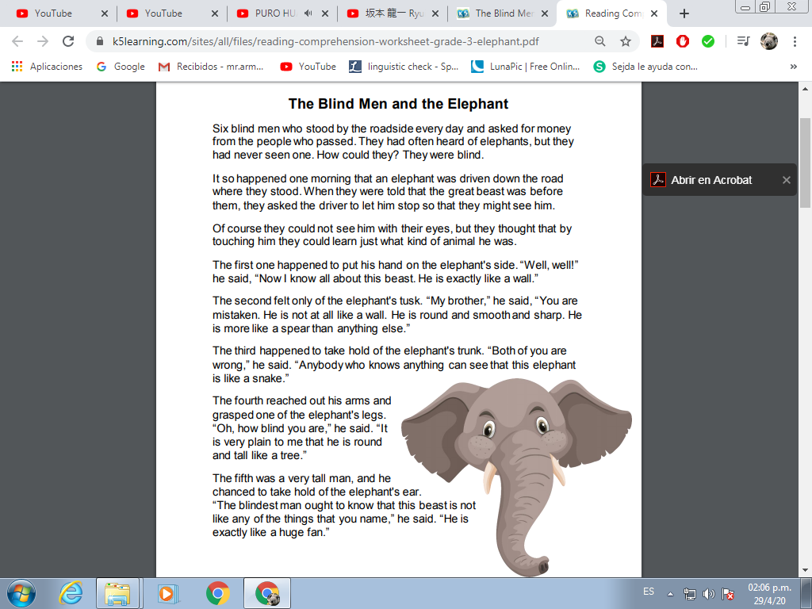
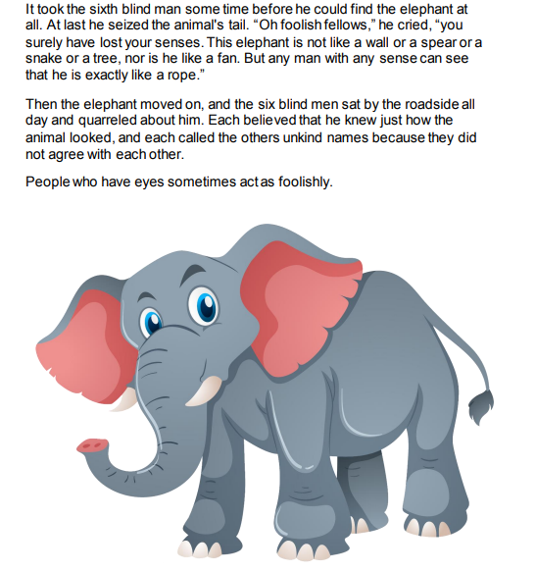

Questions:
- Why were the blind men on the roadside?

_______________________________________________________

- What does the elephant’s ear feel like to one of the men?

_______________________________________________________

- How do the blind men treat one another?

_______________________________________________________

- What does this passage try to each us?

_______________________________________________________

- How many blind men were on the road site?

_______________________________________________________

- Did the blind had heard about the elephants before?

_______________________________________________________

- What was the description of the first blind man?

_______________________________________________________

- What was the first one holding?
_______________________________________________________

- What was the description of the second blind man?

_______________________________________________________

- What was the second one holding?

_______________________________________________________

- Are different points of view bad?

_______________________________________________________

- Why do they call bad names to the other blind men?

_______________________________________________________

- What can you see on the image of the story?

_______________________________________________________

