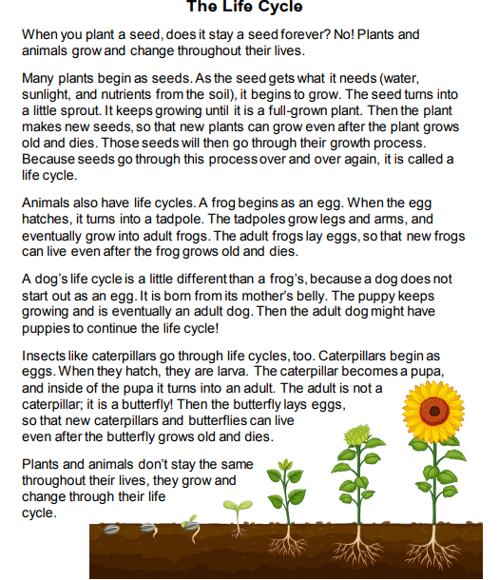

Questions:

- What is the short story mostly about?

_______________________________________________________

- What is a life cycle? Do all life cycles have things in common?

_______________________________________________________

- What is the main topic of the second paragraph?

_______________________________________________________

- Do you know about the life cycle of any other plants or animals?

_______________________________________________________

- Describe it. If not, how could you learn about different life cycles?

_______________________________________________________
- Make the drawing of the life cycle of a Butterfly investigate on internet.

- How many changes does the butterfly have?

- What is the life cycle of a human?

_______________________________________________________

